Using Soundzabound to Find Music
- Go to www.badgerlink.net  **Make sure you have the www. in the beginning of the address or it won’t work** | 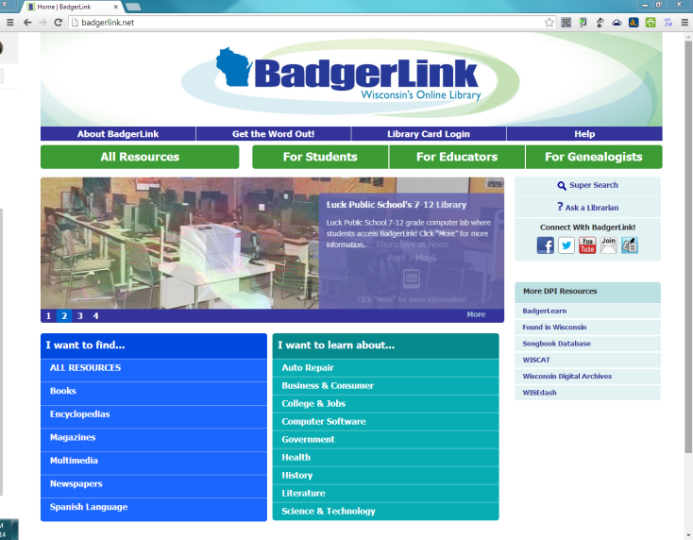
- Click on “All Resources”
- Click on the “S”
- Click on Soundzabound | 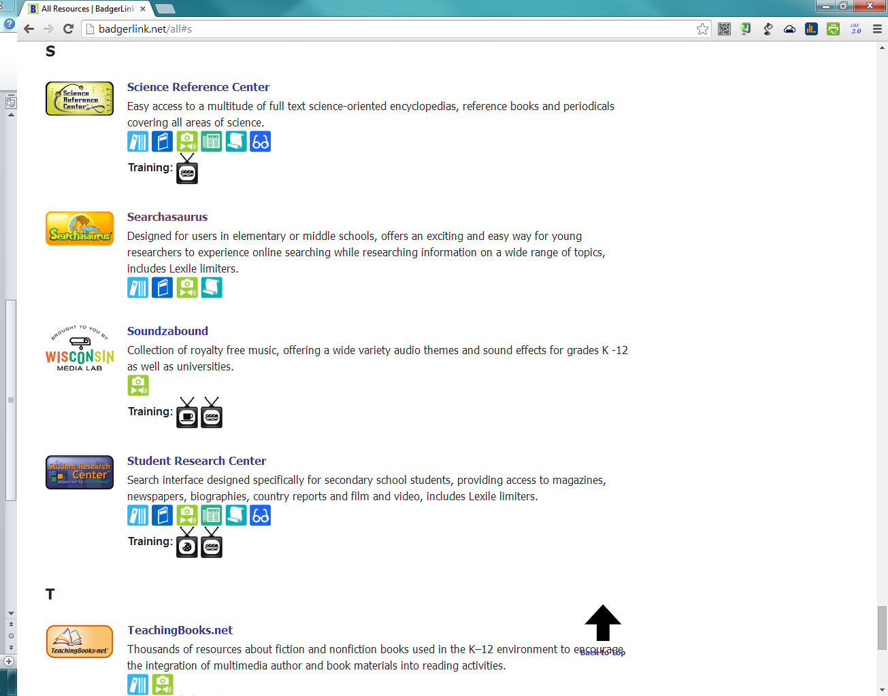
- Click on the “category” link | 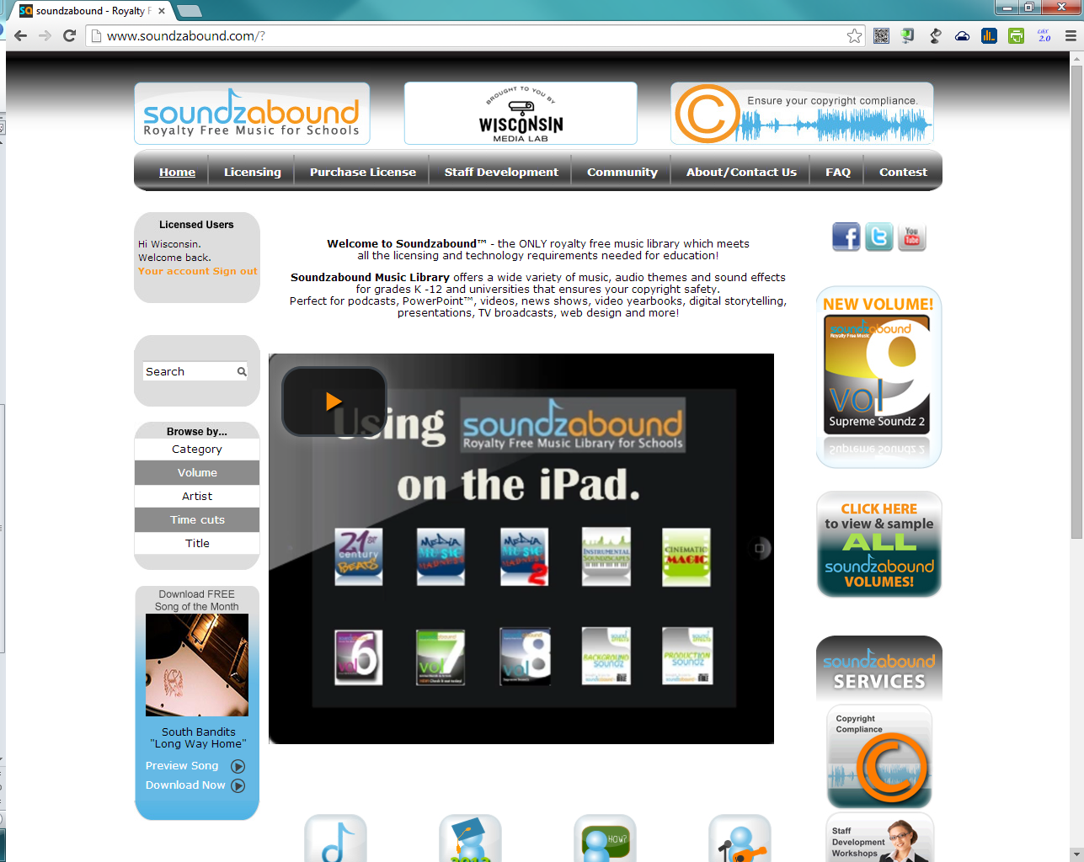
- Browse through the categories looking for a category that might match your book. Click on the name of a category. | 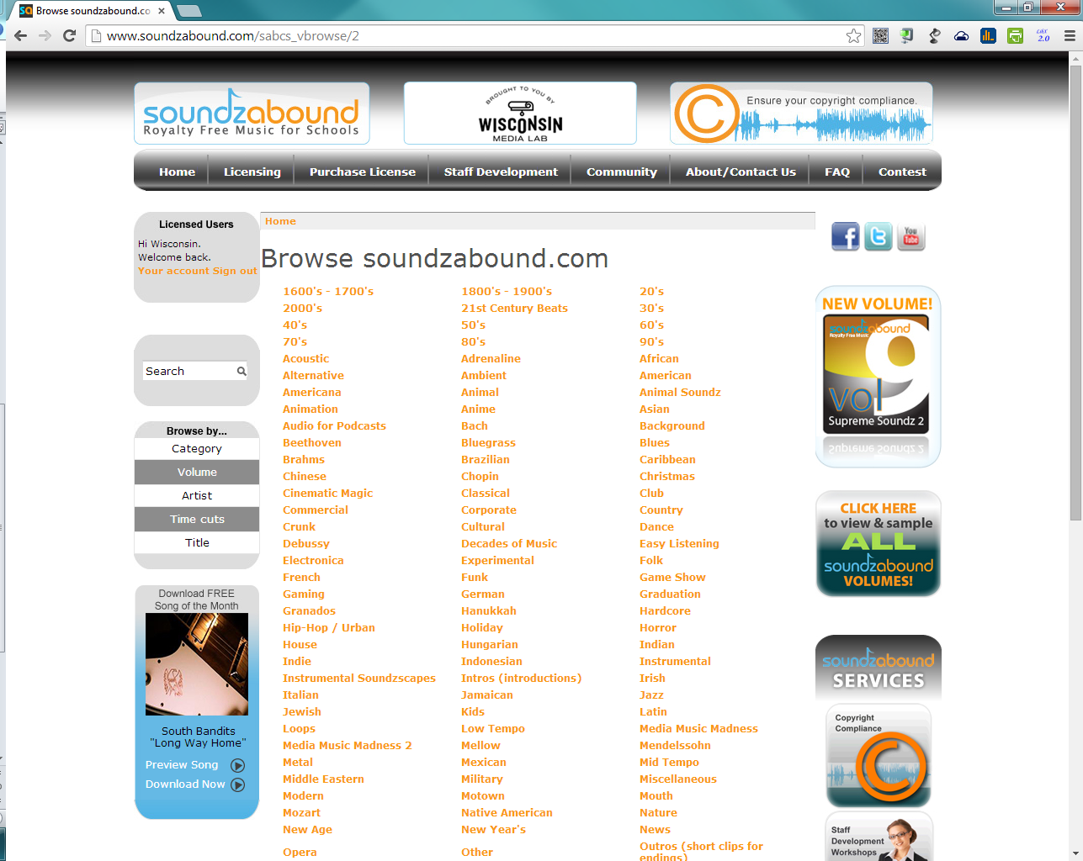
- Click on the play button next to the name of the song to listen to it.

**You should look for a song that is 1-2 minutes in length so it is long enough for all of your pictures and words for your book trailer. **
- When you find a song you like, right-click on the “Download MP3” icon.
- Click on “Save Link As”
- Find the folder you are saving all your pictures to. Rename the song to a name you will remember. Click “Save”.

After you have all of your images and your music clip saved:
- Visit www.ams-ahslibrary.weebly.com.
- Under the “Class” menu bar at the top, click on “Book Trailer Project”.
- Watch the tutorial video on using Animoto.
- Ask Mrs. Falteisek for your username and password for Animoto
- Go to www.animoto.com. Use the username/password your group received and start creating your video.

